3GPP TS 29.521 V15.2.0 (2018-12)
Technical Specification
3rd Generation Partnership Project;
Technical Specification Group Core Network and Terminals;
5G System; Binding Support Management Service;
Stage 3
(Release 15)


The present document has been developed within the 3rd Generation Partnership Project (3GPP TM) and may be further elaborated for the purposes of 3GPP.
The present document has not been subject to any approval process by the 3GPP Organizational Partners and shall not be implemented.
This Specification is provided for future development work within 3GPP only. The Organizational Partners accept no liability for any use of this Specification.
Specifications and Reports for implementation of the 3GPP TM system should be obtained via the 3GPP Organizational Partners' Publications Offices.

Keywords

3GPP
Postal address

3GPP support office address
650 Route des Lucioles - Sophia Antipolis
Valbonne - FRANCE
Tel.: +33 4 92 94 42 00 Fax: +33 4 93 65 47 16
Internet
http://www.3gpp.org
Copyright Notification
No part may be reproduced except as authorized by written permission.
The copyright and the foregoing restriction extend to reproduction in all media.

© 2018, 3GPP Organizational Partners (ARIB, ATIS, CCSA, ETSI, TSDSI, TTA, TTC).
All rights reserved.

UMTS™ is a Trade Mark of ETSI registered for the benefit of its members
3GPP™ is a Trade Mark of ETSI registered for the benefit of its Members and of the 3GPP Organizational Partners
LTE™ is a Trade Mark of ETSI registered for the benefit of its Members and of the 3GPP Organizational Partners
GSM® and the GSM logo are registered and owned by the GSM Association
Contents
Foreword 5
1 Scope 6
2 References 6
3 Definitions and abbreviations 7
3.1 Definitions 7
3.2 Abbreviations 7
4 Binding Support Management Service 7
4.1 Service Description 7
4.1.1 Overview 7
4.1.2 Service Architecture 7
4.1.3 Network Functions 8
4.1.3.1 Binding Support Function (BSF) 8
4.1.3.2 NF Service Consumers 8
4.2 Service Operations 9
4.2.1 Introduction 9
4.2.2 Nbsf_Management_Register Service Operation 9
4.2.2.1 General 9
4.2.2.2 Register a new PCF Session binding information 9
4.2.3 Nbsf_Management_Deregister Service Operation 10
4.2.3.1 General 10
4.2.3.2 Deregister an individual PCF Session binding information 10
4.2.4 Nbsf_Management_Discovery Service Operation 10
4.2.4.1 General 10
4.2.4.2 Retrieve the PCF Session binding information for a given tuple 11
5 Nbsf_Management Service API 11
5.1 Introduction 11
5.2 Usage of HTTP 12
5.2.1 General 12
5.2.2 HTTP standard headers 12
5.2.2.1 General 12
5.2.2.2 Content type 12
5.2.3 HTTP custom headers 12
5.2.3.1 General 12
5.3 Resources 12
5.3.1 Resource Structure 12
5.3.2 Resource: PCF Session Bindings 13
5.3.2.1 Description 13
5.3.2.2 Resource definition 13
5.3.2.3 Resource Standard Methods 13
5.3.2.3.1 POST 13
5.3.2.3.2 GET 14
5.3.3 Resource: Individual PCF Session Binding 14
5.4 Custom Operations without associated resources 15
5.5 Notifications 15
5.6 Data Model 15
5.6.1 General 15
5.6.2 Structured data types 16
5.6.2.1 Introduction 16
5.6.2.2 Type PcfBinding 17
5.6.3 Simple data types and enumerations 17
5.6.3.1 Introduction 17
5.6.3.2 Simple data types 17
5.7 Error handling 17
5.8 Feature negotiation 18
5.9 Security 18
Annex A (normative): OpenAPI specification 19
A.1 General 19
A.2 Nbsf_Management API 19
Annex C (informative): Change history 23

Foreword
This Technical Specification has been produced by the 3rd Generation Partnership Project (3GPP).
The contents of the present document are subject to continuing work within the TSG and may change following formal TSG approval. Should the TSG modify the contents of the present document, it will be re-released by the TSG with an identifying change of release date and an increase in version number as follows:
Version x.y.z
where:
x the first digit:
1 presented to TSG for information;
2 presented to TSG for approval;
3 or greater indicates TSG approved document under change control.
y the second digit is incremented for all changes of substance, i.e. technical enhancements, corrections, updates, etc.
z the third digit is incremented when editorial only changes have been incorporated in the document.

1 Scope
The present specification provides the stage 3 definition of the Binding Support Management Service of the 5G System.
The 5G System Architecture is defined in 3GPP TS 23.501 [2]. The stage 2 definition and related procedures for Binding Support Management Service is specified in 3GPP TS 23.502 [3] and 3GPP TS 23.503 [4].
The 5G System stage 3 call flows are provided in 3GPP TS 29.513 [5].
The Technical Realization of the Service Based Architecture and the Principles and Guidelines for Services Definition are specified in 3GPP TS 29.500 [6] and 3GPP TS 29.501 [7].
The Binding Support Management Service is provided by the Binding Support Function (BSF).

2 References
The following documents contain provisions which, through reference in this text, constitute provisions of the present document.
- References are either specific (identified by date of publication, edition number, version number, etc.) or non-specific.
- For a specific reference, subsequent revisions do not apply.
- For a non-specific reference, the latest version applies. In the case of a reference to a 3GPP document (including a GSM document), a non-specific reference implicitly refers to the latest version of that document in the same Release as the present document.
[1] 3GPP TR 21.905: "Vocabulary for 3GPP Specifications".
[2] 3GPP TS 23.501: "System Architecture for the 5G System; Stage 2".
[3] 3GPP TS 23.502: "Procedures for the 5G System; Stage 2".
[4] 3GPP TS 23.503: "Policy and Charging Control Framework for the 5G System; Stage 2".
[5] 3GPP TS 29.513: "5G System; Policy and Charging Control signalling flows and QoS parameter mapping; Stage 3".
[6] 3GPP TS 29.500: "5G System; Technical Realization of Service Based Architecture; Stage 3".
[7] 3GPP TS 29.501: "5G System; Principles and Guidelines for Services Definition; Stage 3".
[8] IETF RFC 7540: "Hypertext Transfer Protocol Version 2 (HTTP/2)".
[9] IETF RFC 8259: "The JavaScript Object Notation (JSON) Data Interchange Format".
[10] 3GPP TS 29.571: "5G System; Common Data Types for Service Based Interfaces Stage 3".
[11] OpenAPI: "OpenAPI 3.0.0 Specification", https://github.com/OAI/OpenAPI-Specification/blob/master/versions/3.0.0.md.
[12] 3GPP TS 29.510: "5G System; Network Function Repository Services; Stage 3".
[13] IETF RFC 7807: "Problem Details for HTTP APIs".
[14] 3GPP TS 29.213: " Policy and Charging Control signalling flows and Quality of Service (QoS) parameter mapping".
[n2] 3GPP TS 33.501: "Security architecture and procedures for 5G system".
[n3] IETF RFC 6749: "The OAuth 2.0 Authorization Framework".

3 Definitions and abbreviations

3.1 Definitions
For the purposes of the present document, the terms and definitions given in 3GPP TR 21.905 [1] and the following apply. A term defined in the present document takes precedence over the definition of the same term, if any, in 3GPP TR 21.905 [1].

3.2 Abbreviations
For the purposes of the present document, the abbreviations given in 3GPP TR 21.905 [1] and the following apply. An abbreviation defined in the present document takes precedence over the definition of the same abbreviation, if any, in 3GPP TR 21.905 [1].
API Application Programming Interface
BSF Binding Support Function
DRA Diameter Routing Agent
HTTP Hypertext Transfer Protocol
NF Network Function
NRF Network Repository Function

4 Binding Support Management Service

4.1 Service Description

4.1.1 Overview
The Binding Support Management Service as defined in 3GPP TS 23.502 [3] and 3GPP TS 23.503 [4], is provided by the Binding Support Function (BSF).
The Nbsf service is used for the BSF to provide a PDU session binding functionality, which ensures that an AF request for a certain PDU Session reaches the relevant PCF holding the PDU Session information.
This service:
- Allows NF consumers to register, update and remove the binding information; and
- allows NF consumers to retrieve the binding information.

4.1.2 Service Architecture
The 5G System Architecture is defined in 3GPP TS 23.501 [2]. The Policy and Charging related 5G architecture is also described in 3GPP TS 23.503 [4] and 3GPP TS 29.513 [5].
The Binding Support Management Service (Nbsf_Management) is exhibited by the Binding Support Function (BSF).
Known consumers of the Nbsf_management service are:
- Policy Control Function (PCF)
- Network Exposure Function (NEF)
- Application Function (AF)
As described in 3GPP TS 23.503 [4], the BSF is a function that can be deployed standalone or can be the functionality provided by other network functions, such as PCF, UDR, NRF, SMF.
NOTE: The PCF accesses the Nbsf_management service at the BSF via an internal interface when it is collocated with BSF.
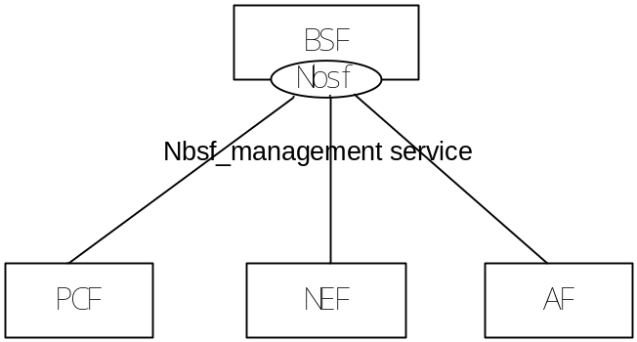
Figure 4.1.2-1: Reference Architecture for the Nbsf_management service; SBI representation

4.1.3 Network Functions

4.1.3.1 Binding Support Function (BSF)
The BSF provides:
- stores the binding information for a certain PDU Session; and
- discovers the selected PCF according to the binding information.
The BSF allows PCFs to register, update and remove the binding information from it, and allows NF consumers to discover the selected PCF.
The BSF can be deployed standalone or can be collocated with other network functions, such as PCF, UDR, NRF andSMF.

4.1.3.2 NF Service Consumers
The Policy Control Function (PCF):
- registers and deregisters the binding information in BSF for a UE when an IP address is allocated , updated or released for a PDU Session.
The Network Exposure Function (NEF):
- provides a means for the Application Functions to securely interact with the Policy framework for policy control to 3GPP network. During the procedure, it needs to discover the selected PCF by using the Nbsf management service discovery service operation.
The Application Function (AF):
- discover the selected PCF by using the Nbsf management service discovery service operation when it is allowed to interact directly with the policy framework for policy control.

4.2 Service Operations

4.2.1 Introduction
Table 4.2.1-1: Operations of the Nbsf_management Service
Service operation name | Description | Initiated by
Nbsf_Management_Register | This service operation is used to register the binding information for a UE when an IP address is allocated for a PDU Session. | NF consumer (PCF)
Nbsf_Management_Deregister | This service operation is used to deregister the binding information for a UE when the PDU Session is released. | NF consumer (PCF)
Nbsf_Management_Discovery | This service operation is used by an NEF or AF to discover a selected PCF . | NF consumer (NEF, AF)

4.2.2 Nbsf_Management_Register Service Operation

4.2.2.1 General
This service operation allows the service consumer to register the session binding information for a UE in the BSF by providing the user identity, the DNN, the UE IP address(es) and the selected PCF address for a certain PDU Session to the BSF, and BSF stores the information.

4.2.2.2 Register a new PCF Session binding information
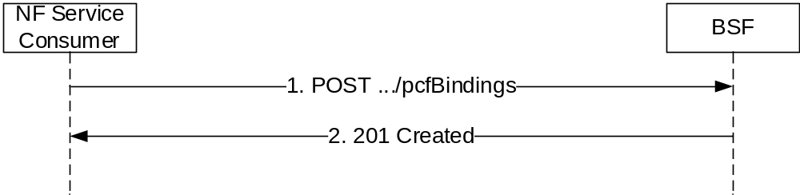
Figure 4.2.2.2-1: NF service consumer register a new PCF Session binding information
The NF service consumer shall invoke the Nbsf_Management_Register service operation to register the session binding information for a UE in the BSF. The NF service consumer shall send an HTTP POST request with "{apiRoot}/nbsf-management/v1/pcfBindings" as Resource URI representing the "PCF Session Bindings", as shown in figure 4.2.2.2-1, step 1, to create a binding information for an "Individual PCF Session Binding" according to the information (e.g. UE address(es), SUPI; GPSI, DNN, S-NSSAI,.NSI) in message body. The PcfBinding data structure provided in the request body shall include:
- UE address(es);
- PCF Id;
and may include:
- DNN;
- SUPI;
- GPSI;
- S-NSSAI, and
- IPv4 address domain.
Upon the reception of an HTTP POST request with: "{apiRoot}/nbsf-management/v1/pcfBindings" as Resource URI and PcfBinding data structure as request body, the BSF shall:
- create new binding information;
- assign a bindingId; and
- store the binding information.
If the BSF created an "Individual PCF Session Binding" resource, the BSF shall respond with "201 Created" with the message body containing a representation of the created binding information, as shown in figure 4.2.2.2.2-1, step 2. The BSF shall include a Location HTTP header field. The Location header field shall contain the URI of the created binding information i.e. "{apiRoot}/nbsf-management/v1/pcfBindings/{bindingId}".

4.2.3 Nbsf_Management_Deregister Service Operation

4.2.3.1 General
This service operation allows the service consumer to remove the session binding information for a UE in the BSF by providing an IP-address for a certain PDU Session to the BSF. It is executed by deleting a given resource identified by an "IP-address". The operation is invoked by issuing a DELETE request on the URI representing the specific session binding information.

4.2.3.2 Deregister an individual PCF Session binding information
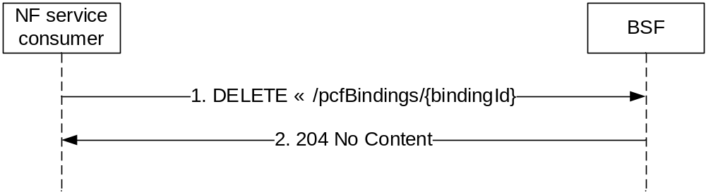
Figure 4.2.3.2-1: Session Binding Information Deregistration
The NF service consumer shall invoke the Nbsf_Management_DeRegister service operation to deregister the session binding information for a UE in the BSF. The NF service consumer shall send an HTTP DELETE request with "{apiRoot}/nbsf-management/v1/pcfBindings/{bindingId}" as Resource URI , where "{bindingId}" is the event subscriptionId of the existing subscription that is to be deleted..
Upon the the reception of an HTTP DELETE request with: "{apiRoot}/nbsf-management/v1/pcfBindings/{bindingId}" as Resource URI, the BSF shall:
- remove the corresponding binding information.
If the HTTP request message from the NF service consumer is accepted, the BSF shall respond with "204 No Content". If the Individual PCF Session Binding resource does not exist, the BSF shall respond with "404 Not Found".

4.2.4 Nbsf_Management_Discovery Service Operation

4.2.4.1 General
This service operation allows the service consumer to use the HTTP GET method to obtain the selected PCF ID.

4.2.4.2 Retrieve the PCF Session binding information for a given tuple
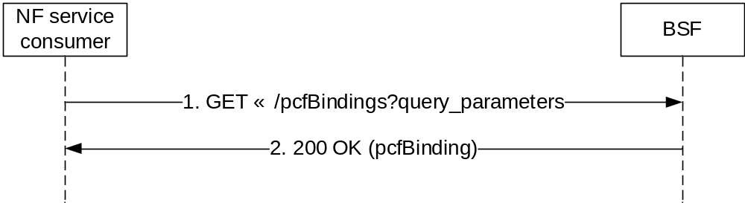
Figure 4.2.4.2-1: NF service consumer retrieve the PCF Session binding information for a given tuple
The NF service consumer shall invoke the Nbsf_Management_Descovery service operation to obtain the selected PCF ID for a PDU session in the BSF. The NF service consumer shall send an HTTP GET request with "{apiRoot}/nbsf-management/v1/pcfBindings?query_parameters" as Resource URI, where query_parameters shall include:
- UE address(es); or
- the tuple UE address, DNN, S-NNSAI; or
- the tuple SUPI, DNN, S-NNSAI; or
- the tuple GPSI, DNN, S-NNSAI; or
- the tuple UE address, DNN, SUPI/GPSI, S-NNSAI.
Upon the the reception of an HTTP GET request with: "{apiRoot}/nbsf-management/v1/pcfBindings?query_parameters" as Resource URI, the BSF shall:
- search the corresponding binding information.
If the HTTP request message from the NF service consumer is accepted, the BSF shall respond the PCF id within the pcfBinding data structure with "200 OK". If the PCF Session Binding resource does not exist, the BSF shall respond with "404 Not Found".

5 Nbsf_Management Service API

5.1 Introduction
The Nbsf_management Service shall use the Nbsf_management API.
The request URI used in each HTTP request from the NF service consumer towards the BSF shall have the structure defined in subclause 4.4.1 of 3GPP TS 29.501 [7], i.e.:
{apiRoot}/{apiName}/{apiVersion}/{apiSpecificResourceUriPart}
with the following components:
- The {apiRoot} shall be set as described in 3GPP TS 29.501 [7].
- The {apiName} shall be "nbsf-management".
- The {apiVersion} shall be "v1".
- The {apiSpecificResourceUriPart} shall be set as described in subclause 5.3.

5.2 Usage of HTTP

5.2.1 General
HTTP/2, IETF RFC 7540 [8], shall be used as specified in clause 5 of 3GPP TS 29.500 [6].
HTTP/2 shall be transported as specified in subclause 5.3 of 3GPP TS 29.500 [6].
The OpenAPI [11] specification of HTTP messages and content bodies for the Nbsf_management is contained in Annex A.

5.2.2 HTTP standard headers

5.2.2.1 General
See subclause 5.2.2 of 3GPP TS 29.500 [6] for the usage of HTTP standard headers.

5.2.2.2 Content type
JSON, IETF RFC 8259 [9], shall be used as content type of the HTTP bodies specified in the present specification as specified in subclause 5.4 of 3GPP TS 29.500 [6]. The use of the JSON format shall be signalled by the content type "application/json".
"Problem Details" JSON object shall be used to indicate additional details of the error in a HTTP response body and shall be signalled by the content type "application/problem+json", as defined in IETF RFC 7807 [13].

5.2.3 HTTP custom headers

5.2.3.1 General
The Nbsf_Management Service API shall support HTTP custom header fields specified in subclause 5.2.3.2 of 3GPP TS 29.500 [6].
In this release of the specification, no specific custom headers are defined for the Nbsf_Management Service API.

5.3 Resources

5.3.1 Resource Structure
The structure of the Resource URI of the Nbsf_Management service is shown in figure 5.3.1-1.
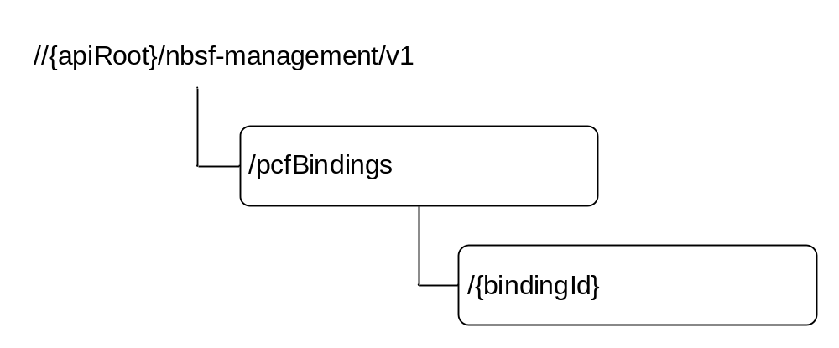
Figure 5.3.1-1: Resource URI structure of the Nbsf_Management API
Table 5.3.1-1 provides an overview of the resources and applicable HTTP methods.
Table 5.3.1-1: Resources and methods overview
Resource name | Resource URI | HTTP method or custom operation | Description
PCF Session Bindings | {apiRoot}/  nbsf-management/v1  /pcfBindings | POST | Register new PCF Session binding information of a given IP address in BSF.
PCF Session Bindings | {apiRoot}/  nbsf-management/v1  /pcfBindings | GET | Retrieve the Session binding PCF ID or address of a given tuple (UE IP address(es), SUPI; GPSI, DNN, snssai).
Individual PCF Session Binding | {apiRoot}/  nbsf-management/v1  /pcfBindings  /{bindingId} | DELETE | Deregister existing PCF Session binding information from BSF.

5.3.2 Resource: PCF Session Bindings

5.3.2.1 Description
This resource represents a collection of the different PCF Session binding information of given IP addresses registered in the BSF.

5.3.2.2 Resource definition
Resource URI: {apiRoot}/nbsf-management/v1/pcfBindings
This resource shall support the resource URI variables defined in table 5.3.2.2-1.
Table 5.3.2.2-1: Resource URI variables for this resource
Name | Definition
apiRoot | See subclause 5.1

5.3.2.3 Resource Standard Methods

5.3.2.3.1 POST
This method shall support the URI query parameters specified in table 5.3.2.3.1-1.
Table 5.3.2.3.1-1: URI query parameters supported by the POST method on this resource
Name | Data type | P | Cardinality | Description
n/a

This method shall support the request data structures specified in table 5.3.2.3.1-2 and the response data structures and response codes specified in table 5.3.2.3.1-3.
Table 5.3.2.3.1-2: Data structures supported by the POST Request Body on this resource
Data type | P | Cardinality | Description
PcfBinding | M | 1..2 | Register a new Individual PCF binding information.

Table 5.3.2.3.1-3: Data structures supported by the POST Response Body on this resource
Data type | P | Cardinality | Response  codes | Description
PcfBinding | M | 1 | 201 Created | The creation of an individual PCF session biding.
NOTE: The mandatory HTTP error status codes for the POST method listed in table 5.2.7.1-1 of 3GPP TS 29.500 [6] shall also apply.

5.3.2.3.2 GET
This method shall support the URI query parameters specified in table 5.3.3.3.1-1.
Table 5.3.2.3.1-1: URI query parameters supported by the GET method on this resource
Name | Data type | P | Cardinality | Description
ipv4Addr | Ipv4Add | C | 0..1 | The IPv4 Address of the served UE.
ipv6Prefix | Ipv6Prefix | C | 0..1 | The IPv6 Address Prefix of the served UE.
macAddr48 | MacAddr48 | C | 0..1 | The MAC Address of the served UE.
dnn | Dnn | C | 0..1 | DNN
supi | Supi | C | 0..1 | Subscription Permanent Identifier
gpsi | Gpsi | C | 0..1 | Generic Public Subscription Identifier
snssai | Snssai | C | 0..1 | The identification of slice.
ipDomain | string | O | 0..1 | The IPv4 address domain identifier.

This method shall support the request data structures specified in table 5.3.3.3.1-2 and the response data structures and response codes specified in table 5.3.3.3.1-3.
Table 5.3.2.3.1-2: Data structures supported by the GET Request Body on this resource
Data type | P | Cardinality | Description
n/a

Table 5.3.2.3.1-3: Data structures supported by the GET Response Body on this resource
Data type | P | Cardinality | Response codes | Description
pcfBinding | M | 1 | 200 OK | The individual PCF session biding session binding information resource matching the query parameter(s) is returned.
ProblemDetails | M | 1 | 404 Not Found | If the PCF Session Binding resource does not exist. (NOTE 2)
NOTE 1: The mandatory HTTP error status codes for the GET method listed in table 5.2.7.1-1 of 3GPP TS 29.500 [6] shall also apply.
NOTE 2: Failure cases are described in subclause 5.7.

5.3.3 Resource: Individual PCF Session Binding

5.3.3.1 Description
This resource represents a collection of the different PCF Session binding information of given IP addresses registered in the BSF.

5.3.3.2 Resource definition
Resource URI: {apiRoot}/nbsf-management/v1/pcfBindings/{bindingId}
This resource shall support the resource URI variables defined in table 5.3.3.2-1.
Table 5.3.3.2-1: Resource URI variables for this resource
Name | Definition
apiRoot | See subclause 5.1
bindingId | Represents the individual PCF Session Binding.  To enable that the value is used as part of a URI, the string shall only contain characters allowed according to the "lower-with-hyphen" naming convention defined in 3GPP TS 29.501 [7].

5.3.3.3 Resource Standard Methods

5.3.3.3.1 DELETE
This method shall support the URI query parameters specified in table 5.3.3.3.2-1.
Table 5.3.3.3.1-1: URI query parameters supported by the DELETE method on this resource
Name | Data type | P | Cardinality | Description
n/a

This method shall support the request data structures specified in table 5.3.3.3.1-2 and the response data structures and response codes specified in table 5.3.3.3.1-3.
Table 5.3.3.3.1-2: Data structures supported by the DELETE Request Body on this resource
Data type | P | Cardinality | Description
n/a

Table 5.3.3.3.1-3: Data structures supported by the DELETE Response Body on this resource
Data type | P | Cardinality | Response codes | Description
n/a |  |  | 204 No Content | Successful case: The Individual PCF session binding information resource is deleted.
ProblemDetails | M | 1 | 404 Not Found | If the Individual PCF Session Binding resource does not exist. (NOTE 2)
NOTE 1: The mandatory HTTP error status codes for the POST method listed in table 5.2.7.1-1 of 3GPP TS 29.500 [6] shall also apply.
NOTE 2: Failure cases are described in subclause 5.7.

5.4 Custom Operations without associated resources
None in this release of this specification.

5.5 Notifications
None in this release of this specification.

5.6 Data Model

5.6.1 General
This subclause specifies the application data model supported by the API.
Table 5.6.1-1 specifies the data types defined for the N_{bsf} service based interface protocol.
Table 5.6.1-1: N_{bsf} specific Data Types
Data type | Section defined | Description | Applicability
PcfBinding | 5.6.2.2 | Identifies an Individual PCF binding.

Table 5.6.1-2 specifies data types re-used by the N_{bsf} service based interface protocol from other specifications, including a reference to their respective specifications and when needed, a short description of their use within the N_{bsf} service based interface.
Table 5.6.1-2: N_{bsf} re-used Data Types
Data type | Reference | Comments | Applicability
DiameterIdentity | 3GPP TS 29.571 [10]
Dnn | 3GPP TS 29.571 [10]
Fqdn | 3GPP TS 29.510 [12]
Gpsi | 3GPP TS 29.571 [10]
IpEndPoint | 3GPP TS 29.510 [12]
Ipv4Addr, | 3GPP TS 29.571 [10]
Ipv6Prefix | 3GPP TS 29.571 [10]
MacAddr48 | 3GPP TS 29.571 [10]
ProblemDetails | 3GPP TS 29.571 [10] | Used in error responses to provide more detailed information about an error.
Snssai | 3GPP TS 29.571 [10]
Supi | 3GPP TS 29.571 [10]
SupportedFeatures | 3GPP TS 29.571 [10] | Used to negotiate the applicability of the optional features defined in table 5.8-1.

5.6.2 Structured data types

5.6.2.1 Introduction
This subclause defines the structures to be used in resource representations.

5.6.2.2 Type PcfBinding
Table 5.6.2.2-1: Definition of type PcfBinding
Attribute name | Data type | P | Cardinality | Description | Applicability
supi | Supi | C | 0..1 | Subscription Permanent Identifier
gpsi | Gpsi | C | 0..1 | Generic Public Subscription Identifier
ipv4Addr | Ipv4Addr | C | 0..1 | The IPv4 Address of the served UE. (NOTE 1)
ipv6Prefix | Ipv6Prefix | C | 0..1 | The IPv6 Address Prefix of the served UE. (NOTE 1)
ipDomain | string | O | 0..1 | IPv4 address domain identifier.
macAddr48 | MacAddr48 | C | 0..1 | The MAC Address of the served UE. (NOTE 1)
dnn | Dnn | M | 1 | DNN
pcfFqdn | Fqdn | C | 0..1 | FQDN of the PCF or the FQDN of the PCF hosting the Npcf_PolicyAuthorization service. (NOTE 2)
pcfIpEndPoints | array(IpEndPoint) | C | 1..N | IP end points of the PCF or the IP end points of the PCF hosting the Npcf_PolicyAuthorization service. (NOTE 2)
pcfDiamHost | DiameterIdentity | C | 0..1 | The diameter host for an individual PCF, it is provided by the PCF supporting Rx interface.
pcfDiamRealm | DiameterIdentity | C | 0..1 | The diameter realm for an individual PCF , it is provided by the PCF supporting Rx interface.
snssai | Snssai | M | 1 | The identification of slice.
NOTE 1: Either IP address(es) ( ipv4Addr, ipv6Prefix) or macAddr48 shall be included.
NOTE 2: At least one of pcfFqdn or pcfIpEndPoints shall be included if the PCF supports N5 interface. If the pcfIpEndPoints is provided at the PCF level, the transport and port in the pcfIpEndPoints are not required.

5.6.3 Simple data types and enumerations

5.6.3.1 Introduction
This subclause defines simple data types and enumerations that can be referenced from data structures defined in the previous subclauses.

5.6.3.2 Simple data types
The simple data types defined in table 5.6.3.2-1 shall be supported.
Table 5.6.3.2-1: Simple data types
Type Name | Type Definition | Description | Applicability
n/a

5.7 Error handling

5.7.1 General
HTTP error handling shall be supported as specified in subclause 5.2.4 of 3GPP TS 29.500 [6].
For the Nbsf_Management Service API, HTTP error responses shall be supported as specified in subclause 4.8 of 3GPP TS 29.501 [7]. Protocol errors and application errors specified in table 5.2.7.2-1 of 3GPP TS 29.500 [6] shall be supported for an HTTP method if the corresponding HTTP status codes are specified as mandatory for that HTTP method in table 5.2.7.1-1 of 3GPP TS 29.500 [6]. In addition, the requirements in the following subclauses shall apply.

5.7.2 Protocol Errors
In this Release of the specification, there are no additional protocol errors applicable for the Nbsf_Management Service API.

5.7.3 Application Errors
The application errors defined for the Nbsf_Management Service API are listed in table 5.7.3-1. The PCF shall include in the HTTP status code a "ProblemDetails" data structure with the "cause" attribute indicating the application error as listed in table 5.7.3-1.
Table 5.7.3-1: Application errors
Application Error | HTTP status code | Description
BINDING_INFORMATION_NOT_FOUND | 404 Not Found | Indicates that the modification has failed because the specified PCF Session Bindings or Individual PCF Session Binding does not exist. (NOTE)
NOTE: This application error is included in the responses to the GET and the DELETE requests.

5.8 Feature negotiation
The optional features in table 5.8-1 are defined for the Nbsf_Management Service API. They shall be negotiated using the extensibility mechanism defined in subclause 6.6 of 3GPP TS 29.500 [6].
Table 5.8-1: Supported Features
Feature number | Feature Name | Description

5.9 Security
As indicated in 3GPP TS 33.501 [n2] and 3GPP TS 29.500 [6], the access to the Nbsf_Management API may be authorized by means of the OAuth2 protocol (see IETF RFC 6749 [n3]), based on local configuration, using the "Client Credentials" authorization grant, where the NRF (see 3GPP TS 29.510 [12]) plays the role of the authorization server.
If OAuth2 is used, a n NF Service Consumer, prior to consuming services offered by the Nbsf_Management API, shall obtain a "token" from the authorization server, by invoking the Access Token Request service, as described in 3GPP TS 29.510 [12], subclause 5.4.2.2.
NOTE: When multiple NRFs are deployed in a network, the NRF used as authorization server is the same NRF that the NF Service Consumer used for discovering the Nbsf_Management service.
The Nbsf_Management API defines a single scope "nbsf-management" for the entire service, and it does not define any additional scopes at resource or operation level.

Annex A (normative):
OpenAPI specification

A.1 General

The present Annex contains an OpenAPI [11] specification of HTTP messages and content bodies used by the Nbsf_Management API.
In case of conflicts between the main body of the present document and the present Annex, the information in the main body shall be applicable.

A.2 Nbsf_Management API
openapi: 3.0.0
info:
description: Binding Support Management Service API
version: "1.0.0"
title: Nbsf_Management
externalDocs:
description: 3GPP TS 29.521 V15.2.0; 5G System; Binding Support Management Service.
url: 'http://www.3gpp.org/ftp/Specs/archive/29_series/29.521/'
servers:
- url: '{apiRoot}/nbsf-management/v1'
variables:
apiRoot:
default: https://example.com
description: apiRoot as defined in subclause 4.4 of 3GPP TS 29.501.
security:
- {}
- oAuth2ClientCredentials:
- nbsf-management
paths:
/pcfBindings:
post:
requestBody:
required: true
content:
application/json:
schema:
$ref: '#/components/schemas/PcfBinding'
responses:
'201':
description: The creation of an individual PCF session binding.
content:
application/json:
schema:
$ref: '#/components/schemas/PcfBinding'
headers:
Location:
description: 'Contains the URI of the newly created resource, according to the structure: {apiRoot}/nbsf-management/v1//pcfBindings/{bindingId}
required: true
schema:
type: string
'400':
$ref: 'TS29571_CommonData.yaml#/components/responses/400'
'401':
$ref: 'TS29571_CommonData.yaml#/components/responses/401'
'403':
$ref: 'TS29571_CommonData.yaml#/components/responses/403'
'404':
$ref: 'TS29571_CommonData.yaml#/components/responses/404'
'411':
$ref: 'TS29571_CommonData.yaml#/components/responses/411'
'413':
$ref: 'TS29571_CommonData.yaml#/components/responses/413'
'415':
$ref: 'TS29571_CommonData.yaml#/components/responses/415'
'429':
$ref: 'TS29571_CommonData.yaml#/components/responses/429'
'500':
$ref: 'TS29571_CommonData.yaml#/components/responses/500'
'503':
$ref: 'TS29571_CommonData.yaml#/components/responses/503'
default:
$ref: 'TS29571_CommonData.yaml#/components/responses/default'
get:
parameters:
- name: ipv4Addr
in: query
description: The IPv4 Address of the served UE.
required: false
schema:
$ref: 'TS29571_CommonData.yaml#/components/schemas/Ipv4Addr'
- name: ipv6Prefix
in: query
description: The IPv6 Address Prefix of the served UE.
required: false
schema:
$ref: 'TS29571_CommonData.yaml#/components/schemas/Ipv6Prefix'
- name: macAddr48
in: query
description: The MAC Address of the served UE.
required: false
schema:
$ref: 'TS29571_CommonData.yaml#/components/schemas/MacAddr48'
- name: dnn
in: query
description: DNN.
required: false
schema:
$ref: 'TS29571_CommonData.yaml#/components/schemas/Dnn'
- name: supi
in: query
description: Subscription Permanent Identifier.
required: false
schema:
$ref: 'TS29571_CommonData.yaml#/components/schemas/Supi'
- name: gpsi
in: query
description: Generic Public Subscription Identifier
required: false
schema:
$ref: 'TS29571_CommonData.yaml#/components/schemas/Gpsi'
- name: snssai
in: query
description: The identification of slice.
required: false
schema:
$ref: 'TS29571_CommonData.yaml#/components/schemas/Snssai'
- name: ipDomain
in: query
description: The IPv4 address domain identifier.
required: false
schema:
type: string
responses:
'200':
description: The individual PCF session binding session binding information resource matching the query parameter(s) is returned.
content:
application/json:
schema:
$ref: '#/components/schemas/PcfBinding'
'400':
$ref: 'TS29571_CommonData.yaml#/components/responses/400'
'401':
$ref: 'TS29571_CommonData.yaml#/components/responses/401'
'403':
$ref: 'TS29571_CommonData.yaml#/components/responses/403'
'404':
$ref: 'TS29571_CommonData.yaml#/components/responses/404'
'406':
$ref: 'TS29571_CommonData.yaml#/components/responses/406'
'414':
$ref: 'TS29571_CommonData.yaml#/components/responses/414'
'429':
$ref: 'TS29571_CommonData.yaml#/components/responses/429'
'500':
$ref: 'TS29571_CommonData.yaml#/components/responses/500'
'503':
$ref: 'TS29571_CommonData.yaml#/components/responses/503'
default:
$ref: 'TS29571_CommonData.yaml#/components/responses/default'
/pcfBindings/{bindingId}:
delete:
parameters:
- name: bindingId
in: path
description: Represents the individual PCF Session Binding.
required: true
schema:
type: string
responses:
'204':
description: No Content. The Individual PCF session binding information resource is deleted.
'400':
$ref: 'TS29571_CommonData.yaml#/components/responses/400'
'401':
$ref: 'TS29571_CommonData.yaml#/components/responses/401'
'403':
$ref: 'TS29571_CommonData.yaml#/components/responses/403'
'404':
$ref: 'TS29571_CommonData.yaml#/components/responses/404'
'429':
$ref: 'TS29571_CommonData.yaml#/components/responses/429'
'500':
$ref: 'TS29571_CommonData.yaml#/components/responses/500'
'503':
$ref: 'TS29571_CommonData.yaml#/components/responses/503'
default:
$ref: 'TS29571_CommonData.yaml#/components/responses/default'
components:
securitySchemes:
oAuth2ClientCredentials:
type: oauth2
flows:
clientCredentials:
tokenUrl: '{nrfApiRoot}/oauth2/token'
scopes:
nbsf-management: Access to the Nbsf_Management API
schemas:
PcfBinding:
type: object
properties:
supi:
$ref: 'TS29571_CommonData.yaml#/components/schemas/Supi'
gpsi:
$ref: 'TS29571_CommonData.yaml#/components/schemas/Gpsi'
ipv4Addr:
$ref: 'TS29571_CommonData.yaml#/components/schemas/Ipv4Addr'
ipv6Prefix:
$ref: 'TS29571_CommonData.yaml#/components/schemas/Ipv6Prefix'
ipDomain:
type: string
macAddr48:
$ref: 'TS29571_CommonData.yaml#/components/schemas/MacAddr48'
dnn:
$ref: 'TS29571_CommonData.yaml#/components/schemas/Dnn'
pcfFqdn:
$ref: 'TS29510_Nnrf_NFManagement.yaml#/components/schemas/Fqdn'
pcfIpEndPoints:
type: array
items:
$ref: 'TS29510_Nnrf_NFManagement.yaml#/components/schemas/IpEndPoint'
minItems: 1
description: IP end points of the PCF or the IP end points of the PCF hosting the Npcf_PolicyAuthorization service. At least one of pcfFqdn or pcfIpEndPoints shall be included if the PCF supports N5 interface. If the pcfIpEndPoints is provided at the PCF level, the transport and port in the pcfIpEndPoints are not required.
pcfDiamHost:
$ref: 'TS29571_CommonData.yaml#/components/schemas/DiameterIdentity'
pcfDiamRealm:
$ref: 'TS29571_CommonData.yaml#/components/schemas/DiameterIdentity'
snssai:
$ref: 'TS29571_CommonData.yaml#/components/schemas/Snssai'
required:
- dnn
- snssai
oneOf:
- anyOf:
- required: [ipv4Addr]
- required: [ipv6Prefix]
- required: [macAddr48]

Annex B (informative):
Deployment option to support BSF and DRA coexistence due to network migration
As described in Annex B of 3GPP TS 23.503 [4], the Diameter Routing Agent (DRA) and the BSF can coexist in an operator's network during the network migration to 5GC. The DRA is described in 3GPP TS 29.213 [14] and can be a service consumer of the Nbsf_Management_Discovery service.
During the Rx session establishment, the DRA can discover the selected PCF for the related subscriber by using the Nbsf_Management_Discovery service operation to obtain the related PCF address if it has no stored binding information derived from an ongoing Gx session for that subscriber.
NOTE 1: For a UE in the EPC there is a Gx session and the DRA stores the binding information. For a UE in the 5GC the Npcf_SmPolicyControl service is used and the BSF stores the binding information.
NOTE 2: If the DRA has no stored binding information derived from an ongoing Gx session for a subscriber, the DRA needs to request new binding information for each Rx session establishment because the information in the BSF could have changed compared to any previous binding information the DRA requested.

Annex C (informative):
Change history
Change history
Date | TSG # | TSG Doc. | CR | Rev | Cat | Subject/Comment | New
2018-01 |  |  |  |  |  | TS skeleton of Binding Support Management Service specification | 0.0.0
2018-01 |  |  |  |  |  | Inclusion of documents agreed in CT3#94 C3-180301, C3-180191, C3-180192 and C3-180193. | 0.1.0
2018-03 |  |  |  |  |  | Inclusion of documents agreed in CT3#95 C3-181350 and C3-181352. | 0.2.0
2018-04 |  |  |  |  |  | Inclusion of documents agreed in CT3#96 C3-182424 and C3-182510. | 0.3.0
2018-05 |  |  |  |  |  | Inclusion of documents agreed in CT3#97 C3-183287, C3-183500, C3-183881, C3-183502 and C3-183733. | 0.4.0
2018-06 | CT#80 | CP-181031 |  |  |  | TS sent to plenary for approval. | 1.0.0
2018-06 | CT#80 | CP-181031 |  |  |  | TS approved by plenary | 15.0.0
2018-09 | CT#81 | CP-182015 | 0001 | 2 | F | PCF id correction for BSF | 15.1.0
2018-09 | CT#81 | CP-182015 | 0002 |  | F | Reference update: OpenAPI specification | 15.1.0
2018-09 | CT#81 | CP-182015 | 0004 | 2 | F | Clarification on mandatory HTTP error status codes | 15.1.0
2018-09 | CT#81 | CP-182015 | 0005 | 6 | B | OpenAPI for TS 29.521 | 15.1.0
2018-09 | CT#81 | CP-182015 | 0006 | 1 | F | Description of Structured data types | 15.1.0
2018-09 | CT#81 | CP-182015 | 0007 | 1 | B | Support of IPv4 overlapping | 15.1.0
2018-09 | CT#81 | CP-182015 | 0008 |  | F | Correction of the service name | 15.1.0
2018-09 | CT#81 | CP-182015 | 0009 | 1 | F | Resource structure presentation | 15.1.0
2018-12 | CT#82 | CP-183205 | 0011 |  | F | Default value for apiRoot Default value for apiRoot | 15.2.0
2018-12 | CT#82 | CP-183205 | 0012 |  | F | Correction to DELETE Method for Nbsf_Management Service API | 15.2.0
2018-12 | CT#82 | CP-183205 | 0013 |  | F | Correction to Typos in URI Paths | 15.2.0
2018-12 | CT#82 | CP-183205 | 0015 |  | F | API version | 15.2.0
2018-12 | CT#82 | CP-183205 | 0016 |  | F | ExternalDocs OpenAPI field | 15.2.0
2018-12 | CT#82 | CP-183205 | 0017 |  | F | Location header field in OpenAPI | 15.2.0
2018-12 | CT#82 | CP-183205 | 0018 | 1 | F | Security | 15.2.0
2018-12 | CT#82 | CP-183205 | 0019 | 1 | F | supported content types | 15.2.0
2018-12 | CT#82 | CP-183205 | 0020 | 2 | F | HTTP Error responses | 15.2.0
2018-12 | CT#82 | CP-183205 | 0021 | 2 | F | DRA as service consumer | 15.2.0
2018-12 | CT#82 | CP-183205 | 0023 |  | F | Change presence in BSF binding | 15.2.0
2018-12 | CT#82 | CP-183205 | 0024 | 1 | F | Presence conditions in yaml file | 15.2.0
2018-12 | CT#82 | CP-183205 | 0025 | 1 | F | Missing 201 response body for POST to /pcfBindings | 15.2.0

